Safeguarding is Everybody’s Business
If you are concerned about the welfare of a child it is your duty as a member of our school community to report it.
The Designated Officer for Child Protection is:
Mrs Moya Whitehead – Headteacher
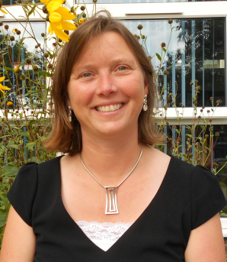
The Designated Deputy for Child Protection is:
Miss Caroline Starr – Wellbeing, Enrichment and Safeguarding
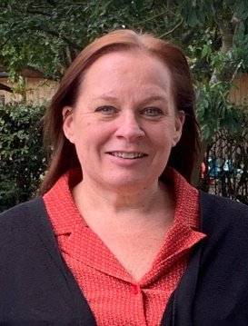

- All staff employed by the school and all school governors should use the agreed protocols for Safeguarding and access MYCONCERN for support.
- All supply/temporary staff should use the ‘visitor information sheet’ provided to signpost them to support.
- All volunteers should seek support from the class teacher and Mrs Whitehead or Miss Starr as required.
- If you are a Parent, Carer, Grandparent or other community member and you have a concern about the wellbeing of a child or family please arrange to speak to Mrs. Whitehead or Miss Starr.

Safeguarding is Everybody’s Business

